**UNIT TEST REPORT**

**CUNIT TESTING-**

CUnit is a lightweight system for writing, administering, and running unit tests in C.  It provides C programmers a basic testing functionality with a flexible variety of user interfaces.

CUnit is built as a static library which is linked with the user's testing code.  It uses a simple framework for building test structures, and provides a rich set of assertions for testing common data types.   In addition, several different interfaces are provided for running tests and reporting results. These interfaces currently include:

1. **OUTPUT OF CUNIT**

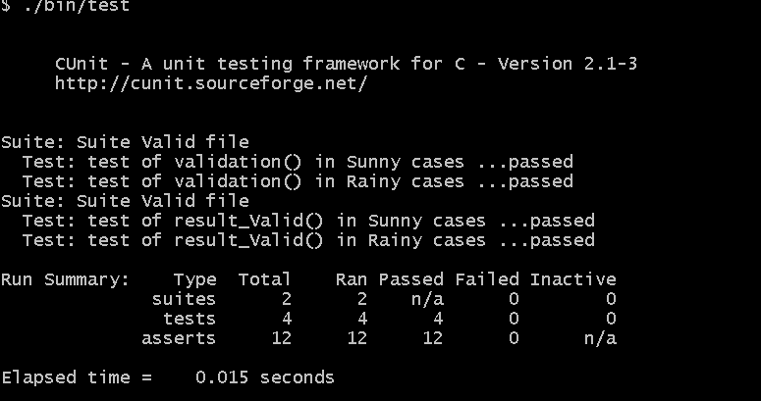

1. **UT_Case 1**

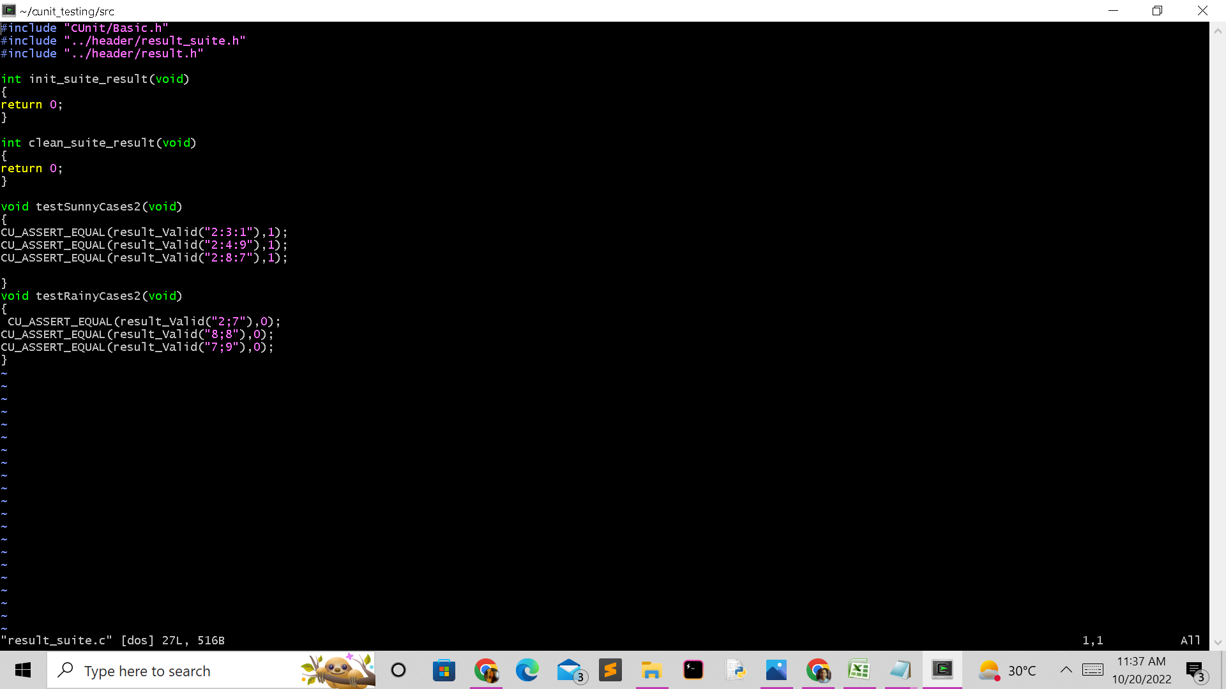

1. **UT_Case 2**

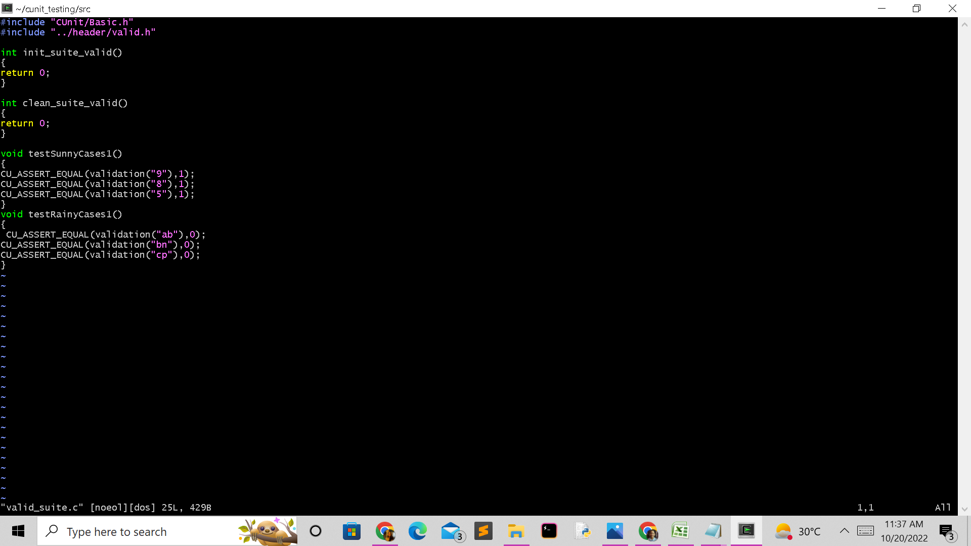

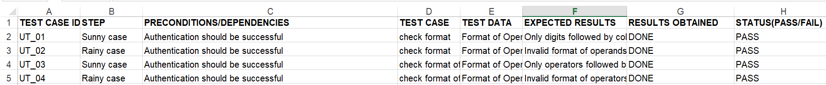

**INTEGRATION TESTING**

**IT_CASE 1:- CHECKING FOR WRONG PASSWORD**

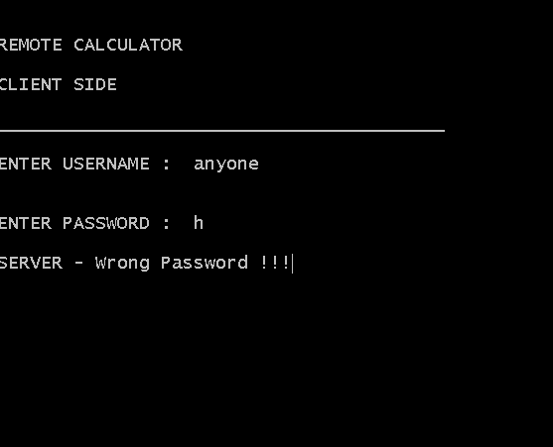

**IT_CASE 2:- CHECKING FOR VARIOUS ARITHMATICAL OPERATIONS:**

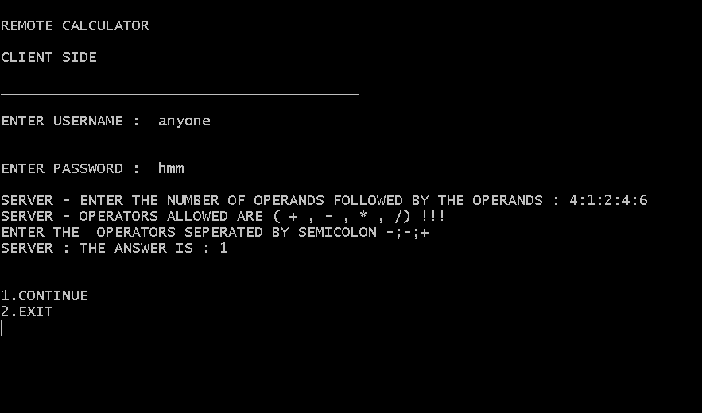

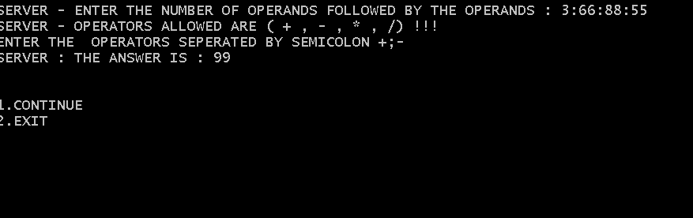

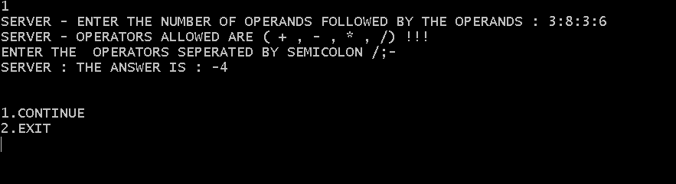

**IT_CASE 3:- CHECKING FOR WRONG FORMAT**

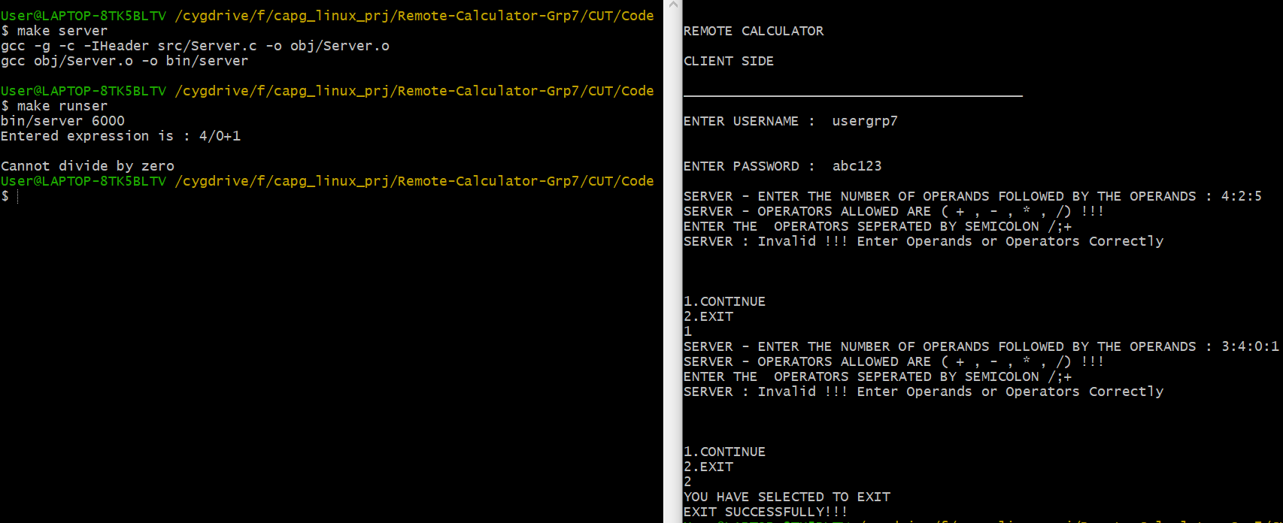

**IT_CASE 4:- OUTPUT ON SERVER SIDE**



